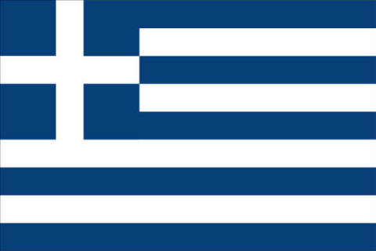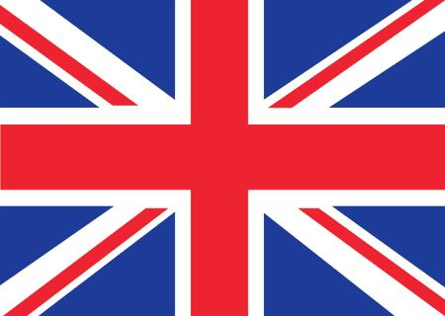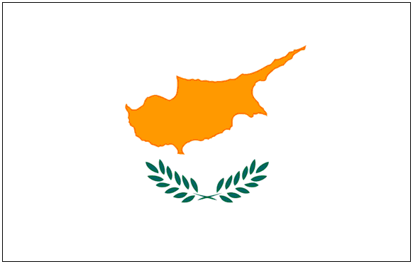

DR ZANNETOS TOFALLIS
ΒΑ, ΜΑ, PhD, FIL

Tel: 020 8445 3324 31 Athenaeum Road
Fax: 020 8446 1448 Whetstone
E-mail: Zannetos@nildram.co.uk LONDON N20 9AL
Website: greektranslations-uk.co.uk
9th June 2008
Dear Colleague,
WEDDINGS IN GREECE - Translations

I am writing to inform you of my services in Greek Translations for your Company’s requirements.

Just a brief reminder about myself: I am a Greek Lecturer, Translator and Writer. I have qualifications from London and Cambridge Universities, the Chartered Institute of Linguists and the Greek Institute and a long experience in translating and interpreting, teaching and lecturing, writing and journalism, editing and broadcasting. I have written several books on the Greek language and culture and lectured widely on Greece and Cyprus. I am one of the official Translators of the Greek Embassy and the Cyprus High Commission in London.

I could undertake work in the following fields: Legal, Tourism, Social, Environmental, Educational, Housing, Arts and Humanities, Finance and Banking, Industry & Commerce, Science & Technology, Media & Advertising, Information Technology, Insurance, Engineering, Architecture, Shipping and many more. I have carried out work for Government Ministries, Municipal Councils, Banks, Law Companies, Accountants and Auditors, Tour Operators, the European Union, Translation Agencies, the Greek General Consulate, the Cyprus High Commission in London.

I am looking forward to our cooperation in the near future.

Kindest regards,
ZANNETOS TOFALLIS
PROFESSIONAL FEES - 2008
(My rates remain the same since 2000)

Minimum Translation Fee £ 30.00
Greek/English & English Greek £ 8.00 @ 100 words
£ 80.00 @ 1000 words
Proofreading £ 30.00 per hour

DR ZANNETOS TOFALLIS
BA, MA, PhD, FCIL
Fellow of the Chartered Institute of Linguists

Greek Lecturer – Translator - Writer

Tel: 020 8445 3324 31 Athenaeum Road
Fax: 020 8446 1448 Whetstone
E-mail: Zannetos@nildram.co.uk LONDON N20 9AL
Website: greektranslations-uk.co.uk

CURRICULUM VITAE

Place of Birth: Styllos, Famagusta, Cyprus
Date of Birth: 26th January 1938
Nationality: British

Education:

English High School, Famagusta, Cyprus
City Literary Institute, London
North Western Polytechnic (now London Metropolitan University)
Wolsey Hall, Oxford
University of Cambridge
University of London

Degrees & Diplomas:

FCIL – Fellow of The Chartered Institute of Linguists - Greek into English
MCIL – Member of The Chartered Institute of Linguists – Diploma of English into Greek
FGI - Fellow of the Greek Institute (Diploma in Modern Greek Studies)
CPE Diploma, Cambridge University (Diploma in English Studies)
University of London (BA Degree Greek Classical, Modern Greek & History); and
ΜΑ and PhD. Degrees in Greek Literature, History and Philosophy

Teaching & Lecturing:
(Modern Greek, Classical Greek, Ancient History and Classical Civilization)

Shelburne Secondary School
Central Foundation Grammar School
Kingsway College
Waltham Forest College
City Literary Institute
Camden Institute
Hampstead Institute
The Mary Ward Centre
City University
University of London

Broadcasting:
London Greek Radio (Founder and former Director)

Greek Tutor & Examiner:
(Modern Greek, Classical Greek, Ancient History and Classical Civilization)

The Linguaphone Institute
Wolsey Hall, Oxford
National Extension College, Cambridge
Civil Service Commission
The Chartered Institute of Linguists
University of London

Translator, Journalist, Writer and Broadcaster:

Freelance Translator and Interpreter since 1966 for EEC, Government Departments, Municipal Councils, solicitors' firms, Greek General Consulate, translating agencies on commercial, cultural, legal, literary, scientific, medical, telecommunications, etc.

Also, I translated Greek literature into English and English literature into Greek (poems by Cavafy, Seferis, Elytis, Varnalis, Ritsos, Anthias, etc.).

I have worked, full time, for VEMA, the London Greek Newspaper, and freelance journalist for a number of years. I published many articles on Greek and Cypriot history, literature and culture.

Freelance journalist and writer for PARIKIAKI, the London Greek Newspaper in London since 1974.
.
Wrote several books on Greece and the Greek language, literature and culture, including GREEK IN THREE MONTHS and SPEAK GREEK TODAY; Also research studies on: Greek Literature from Homer to the Present Day, Aeschylus and the Origins of Greek Drama, Hellenistic Literature, Outlines of Modern Greek History, The Greek Orthodox Church.

Founder and first Managing Director of London Greek Radio (LGR), from 1984 to 90; freelance writer for the Greek Radio since 1990

Member to Professional Societies:

The Greek Institute - Fellow in Modern Greek Studies
The Chartered Institute of Linguists - Fellow and Member in English & Greek
Founder and President - The Anglo-Greek Friendship Society
Founder and President - Styllos Social & Cultural Association
Founder and President - Barnet Cypriot Association
Founder and Hon. President of LELA - Society of Greek Cypriot Writers

